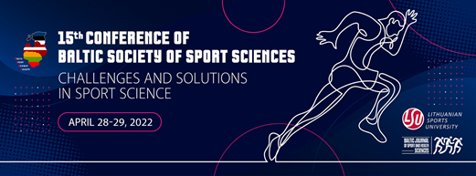

Dear Colleagues and Partners,

We warmly invite you to take part the **15th Baltic  Sport Science Conference** **“CHALLENGES AND SOLUTIONS IN SPORT SCIENCE**” hosted by the Lithuanian Sports University which will take place **on April 28-29, 2022** **ONLINE**.

This annual international event brings together teachers, research fellows and PhD students of Universities and higher education institutions from the Baltic States and other countries to share the latest research findings in sport science.

**Keynote speakers:**

* **Dr. Alīna KURMĒĻEVA**, Latvian Academy of Sport Education, Latvia
* **Prof. Dr. Bruno FIGUEIRA**, Vytautas Magnus University, Education Academy, Lithuania
* **Dr. Eva-Maria RISO**, University of Tartu, Estonia
* **Prof. Dr. Sigitas KAMANDULIS**, Lithuanian Sports University, Lithuania
* **Prof. Dr.** **Jerzy SADOWSKI**, Józef Piłsudski University of Physical Education in Warsaw, Poland

**Conference Sections:**

* Pedagogy and Psychology in Sport
* Sport Management and Sociology
* Sports Physiology, Biochemistry and Medicine
* Physical Activity, Recreation and Health
* Coaching and Performance

For more information, please visit [**the conference website**](https://www.lsu.lt/mokslas/mokslo-rezultatai-ir-ju-viesinimas/mokslo-renginiai/konferencijos/the-15th-conference-of-the-baltic-sport-science-society).

If you have any questions, please contact us by email: [bsssc22@lsu.lt](mailto:bsssc22@lsu.lt)

We are looking forward to welcoming  you in the Conference online!

***Tomas Kukenys*** *Conference Organising Committee  
International Relations Office*

 *Sporto g. 6, LT-44221 Kaunas, Lithuania  
Tel.: +370 690 09921, Mobile: +370 616 76998*[*tomas.kukenys@lsu.lt*](tomas.kukenys@lsu.lt)*,* [*www.lsu.lt*](http://www.lsu.lt/)