**Dear Ladies and Gentlemen,**

**Come and join the Bayreuth International Summer School in Bavaria: 1 - 15 July 2018! Till the 28th of February we still have our reduced fee of 840 Euros. So be quick.**

From 1 to 15 July 2018, the [Bayreuth International Summer School (BISS)](http://www.summerschool.uni-bayreuth.de/en/index.html) will welcome students from all over the world to join courses on the campus of the University of Bayreuth. As one of Germany’s youngest universities, our interdisciplinary focus and the innovative collaboration between many of our disciplines are key features of Bayreuth’s research culture. The University of Bayreuth is considered to be among the best young universities in the world, as can be seen by its position in the Times Higher Education (THE) worldwide ranking "150 under 50". Thanks to its diverse array of disciplines and strategically chosen focus areas, the University of Bayreuth is internationally recognized for its research contributions and offers an excellent study environment.

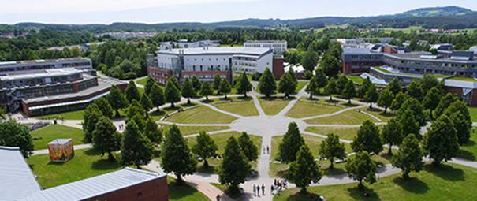

The Bayreuth International Summer School 2018 (1 to 15 July) consists of seven individual courses, each one specialised in a different area of study and research. Organized by the International Office in corporation with the *Campus-Akademie*, all courses are conducted in English by international guest lecturers and will take place over a two-week period. Participants have the opportunity to engage theoretically and practically in various seminars and discussions for around six hours each day. The courses are in line with the research areas of the University of Bayreuth.

Come and be a part of our tight-knit campus and Bavaria’s fun-loving town of Bayreuth, which is firmly in the hands of the students. Enjoy learning and working in a small group of max. 15-20 international participants. A certificate and ECTS points are awarded for regular attendance of the course, active participation and a short presentation. For details concerning ECTS credits, please check the programme information of the particular course.

**Courses 2018**

[Economics & Management](http://www.summerschool.uni-bayreuth.de/en/Courses-2018/Economics-_-Management/index.html)

[African Studies](http://www.summerschool.uni-bayreuth.de/en/Courses-2018/African-Studies/index.html)

[Public Health & Global Change](http://www.summerschool.uni-bayreuth.de/en/Courses-2018/Public-Health/index.html)

[Energy & Climate](http://www.summerschool.uni-bayreuth.de/en/Courses-2018/Energy-_-Climate/index.html)

[Polymer Science & Engineering](http://www.summerschool.uni-bayreuth.de/en/Courses-2018/Advanced-Polymers/index.html)

[Polymer Science & Biofabrication](http://www.summerschool.uni-bayreuth.de/en/Courses-2018/Advabced-Polymers-Bio/index.html)

[International Comparative Law](http://www.summerschool.uni-bayreuth.de/en/Courses-2018/International-Comparative-Law/index.html)

**Facts in a nutshell**

Application possible from 15 January to 30 April 2018

Early bird rate:  840 € (until 28 February 2018)

Regular rate:     940 €

Rate includes:   course fees, lunch, a welcome and farewell dinner, excursion

Kind Regards

Anna Weber

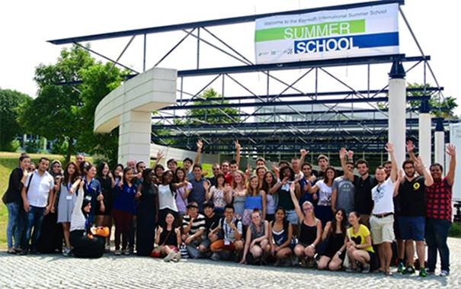

Button:

<http://www.summerschool.uni-bayreuth.de>

Social media links:

<https://www.facebook.com/SummerSchoolBayreuth/>

<https://twitter.com/unibt>

<https://www.instagram.com/uni.bayreuth/>

<https://www.youtube.com/user/unibayreuth>

<https://www.linkedin.com/school/university-of-bayreuth/>

Contact information:

[summerschool@uni-bayreuth.de](mailto:summerschool@uni-bayreuth.de)